Tunnels Instructions:

Controls:

1. WASD –> Walk
2. WASD + SHIFT –> Run
3. Mouse Motion –> Look Around
4. Mouse Click –> Fire Weapon
5. R –> Reload Weapon
6. F –> Buy Ammo at Ammo Refill Station and Open Doors

Goal: Accumulate points by shooting and killing enemies. Use points to open doors and escape the tunnels! However, the more enemies you kill, the stronger they get. Enemies can hurt you, but you will recover health over time.

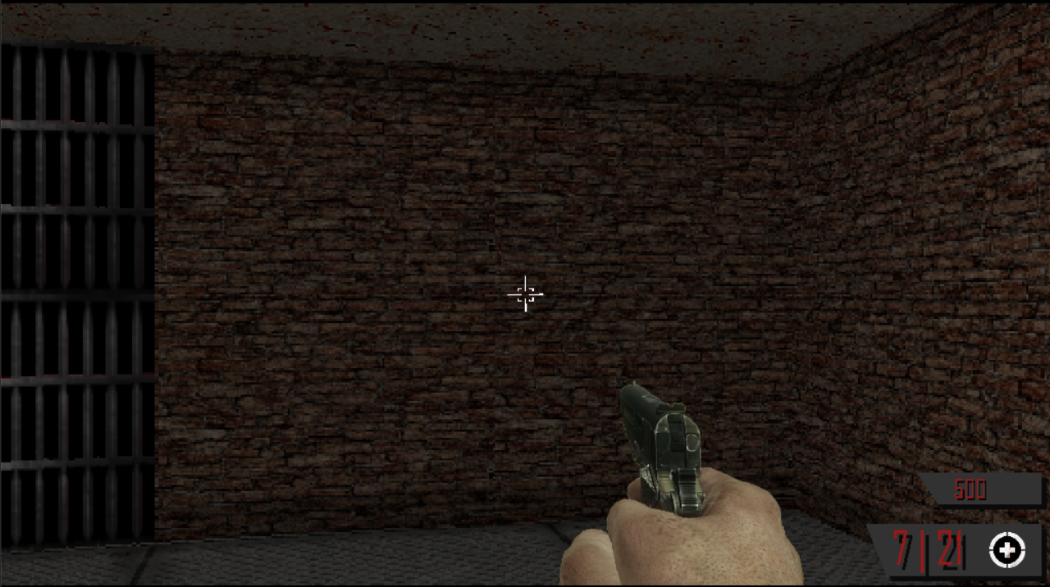

Health Indicator

Points

Ammo Amount

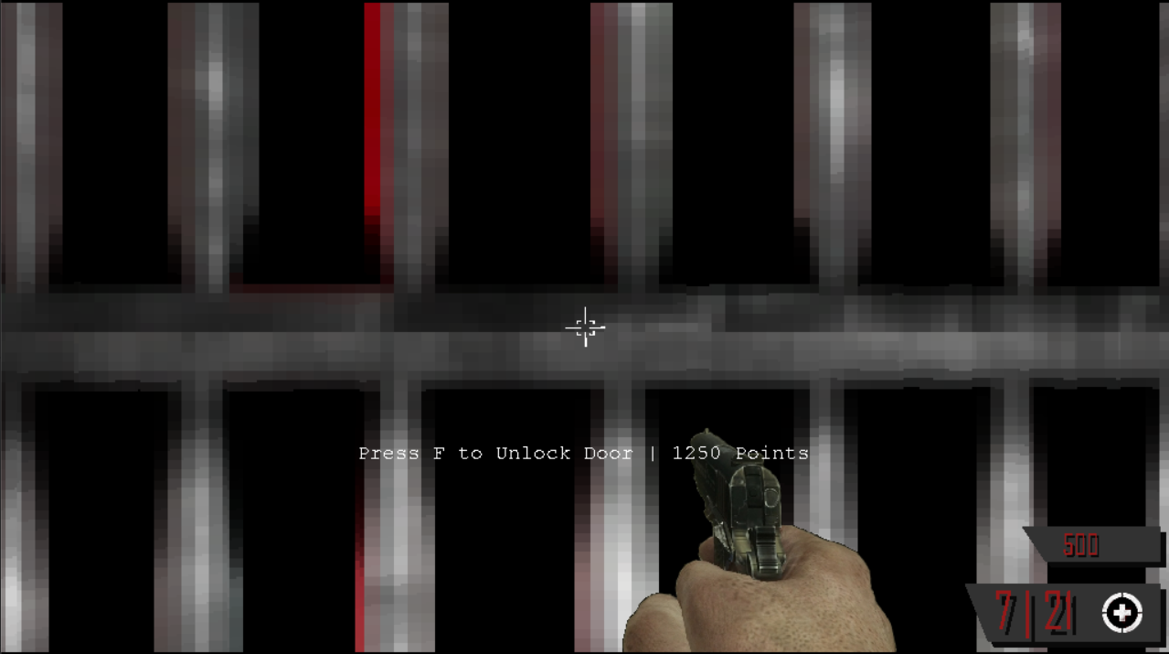

You can walk up to doors and purchase them with points.

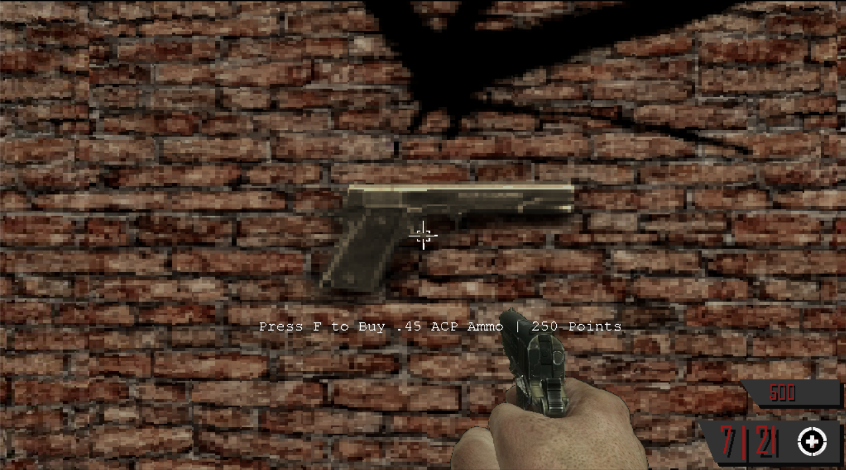

You can walk up to the gun in the starting room and purchase ammo with points.

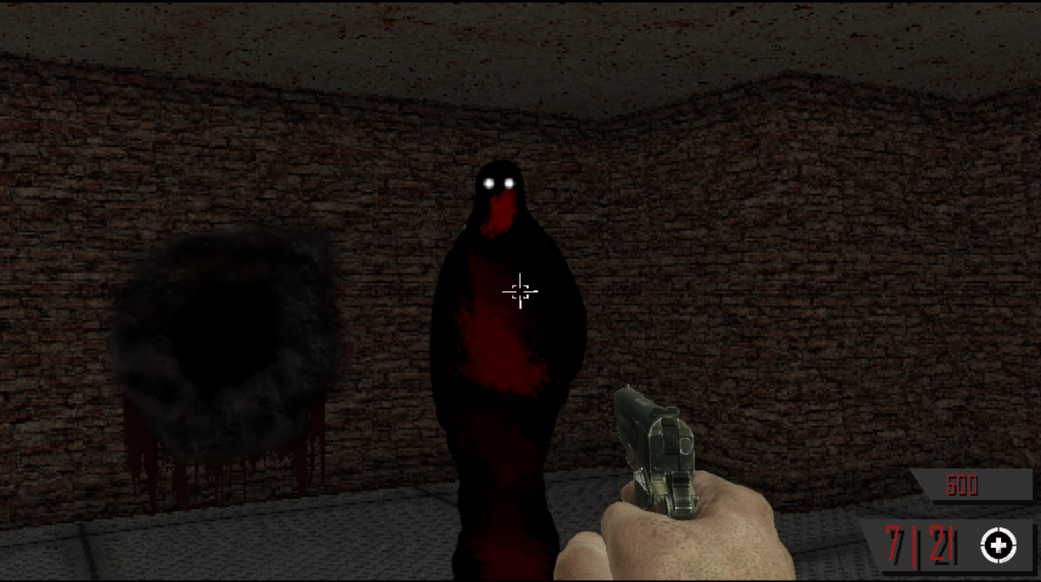

Ghost enemy

Ghosts come from holes in the walls.